**Experiment 1.2**

**Student Name: Yash Gupta UID: 20BCS5009**

**Branch: BE-CSE Section/Group:20BCS_DM-716 B**

**Semester: 6 Date of Performance: 20/02/23**

**Subject Name: IOT LAB Subject Code: 20CSP_358**

## Aim:

Identification of different sensors used in IOT applications.

## Objective:

* To study hardware and software related to IOT.
* To understand and identify different sensors used in IOT.

**Sensors:** The sensors are defined as a machine, module, or a device that detect changes in the environment.

The sensor is a device, which is made up of Single Crystal Silicon. It is considered as a widely used semiconductor material. It has superior mechanical stability, machinability, etc. It can also combine electronics.

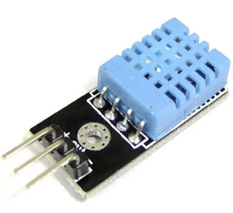**1. Temperature sensors**

Used to measure physical change in the temperature from a source and converts the data as per requirement.

Ex: - A/C controller, Refrigerator, etc.

Sub-categories of temp sensor –

Thermocouples, Resistor temperature detector (RTD), Thermistors, IC, Infrared Sensors.

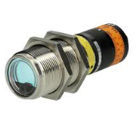**2. Proximity sensor**

**Detects the presence or absence of a nearby object. Which can be easily read by users.**

**Ex: - Reverse parking, Automated door, etc.**

Sub-categories of proximity sensor –

Inductive sensor, Capacitive Sensor, Photoelectric Senser, Ultrasonic Sensor, etc.

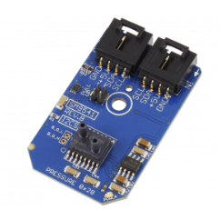**3. Pressure Senser**

Pressure sensor senses and converts the data into electrical signal.

Ex: - Medical application, Refrigeration system, etc.

**5. Water Quality Sensor**

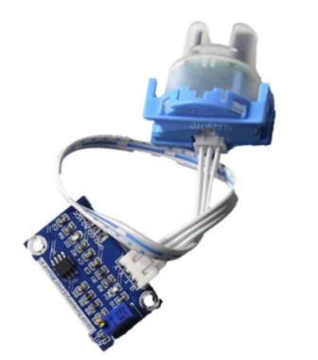Used to detect the water quality and Ion monitoring primarily in water distribution system**.**

**Ex: - Water filter**

**Types of water sensor –**

**Chlorine Residual Sensor, Total Organic Carbon Sensor, Turbidity Sensor, pH Sensor, Oxygen-Reduction Potential Sensor.**

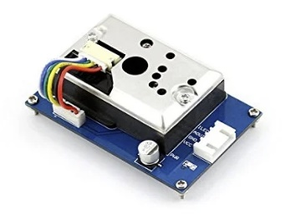**5. Chemical Sensor**

**It is used to indicate changes in liquid or to find air chemical changes.**

**Ex: - Environmental monitoring, harmful chemical release detection, etc .**

**Types of chemical sensor –**

Chemical field-effect transistor, Chemiresistor, Electrochemical gas sensor, Fluorescent chloride sensor, Hydrogen sulfide sensor, Nondispersive infrared sensor, pH glass electrode.

6. Gas Sensor

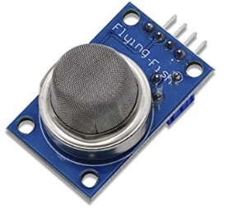**Used to monitor changes of the air** quality and detect the presence of various gases.

Ex: - Air quality monitoring, agriculture, health industry, etc.

Types of Gas Sensor –

Carbon dioxide sensor, Breathalyzer, Carbon monoxide detector, Catalytic bead sensor.

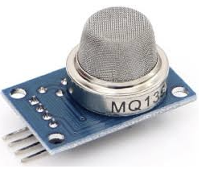**7. Smoke Sensor –**

A smoke sensor is a device that senses smoke.

**Ex: - Fire alarm at home**

**Types of Smoke Sensor –**

**Optical smoke sensor, Ionization smoke sensor.**

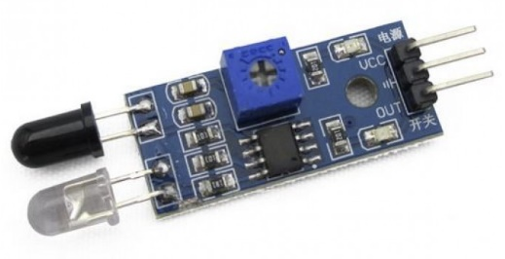**8. IR Sensor –**

Used to sense certain characteristics of its surroundings by either emitting or detecting infrared radiation. It is also capable of measuring the heat being emitted by objects.

**Ex: - Breath analysis,** monitor blood flow, temperature detection.

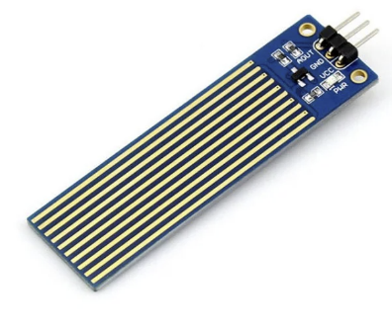**9. Level Sensor –**

Used to determine the level of fluids, liquids or other substances that flow in an open or closed system.

**Ex: - Tank water level indicator.**

**Types of Level measurement sensor –**

**Point level sensor, Continuous level sensor.**

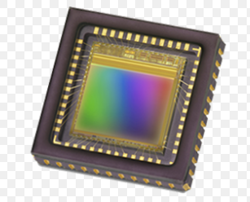**10. Image Sensor –**

Used to convert optical images into electronic signals for displaying or storing files electronically.

**Ex: - Mobile, Security cam, Camera.**

**11. Motion detection sensor –**

Used to detect the physical movement in a given area and it transforms motion into an electric signal; motion of any object or motion of human beings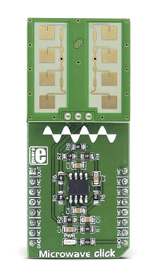.

Ex: - Automatic door control, boom barrier, smart camera.

Types of motion detection sensor –

Passive Infrared (PIR), Ultrasonic, Microwave.

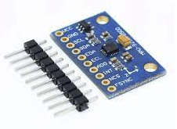**12. Accelerometer Sensors –**

Is a transducer, used to measure the physical acceleration experienced by an object due to inertial forces and converts the mechanical motion into an electrical output. It is defined as rate of change of velocity with respect to time

**Ex: - Antitheft in objects, Aircraft, Media devices.**

**Types of accelerometer –**

**Hall effect accelerometer, Capacity accelerometer, Piezoelectric accelerometer.**

**13. Gyroscope Sensor –**

Used to measure the angular rate or velocity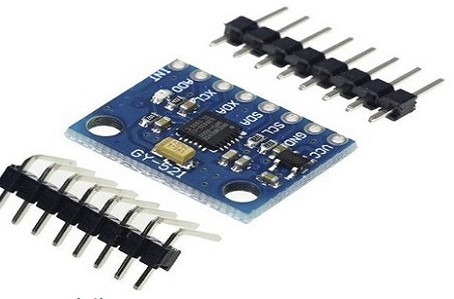 in 3 - axis.

Ex: - Car navigation system, Drone, Mobile phone.

**Types of gyro sensor –**

Rotary gyroscopes, Vibrating Structure Gyroscope, Optical Gyroscopes, MEMS Gyroscopes.